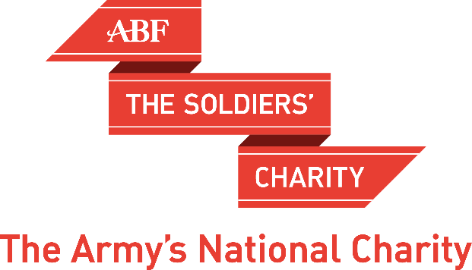

Andrew Roberts

‘Leadership in War’

The Inner London Committee of ABF The Soldiers’ Charity invites you to a drinks reception followed by a talk at:

London Scottish House, 95 Horseferry Road, Westminster, London SW1P 2DX

On Tuesday 5th November 2019 – Drinks at 6:30pm for a 7:15pm talk

Taking us from the French Revolution to the Cold War and the Falklands, Andrew Roberts presents us with a bracingly honest and insightful look at nine major figures in modern history. Each of these leaders fundamentally shaped the outcome of the war their nation was embroiled in. How were they alike, and in what ways did they differ? Was their war leadership unique, or did these leaders have something in common, traits and techniques that transcend time and place and can be applied to the fundamental nature of conflict? Andrew offers fresh, complex portraits of leaders who approached war with different tactics and different weapons, but with the common goal of success in the face of battle. Both inspiring and cautionary, these portraits offer important lessons on leadership in times of struggle. With his trademark verve and incisive observation, Andrew reveals the qualities that doom even the most promising leaders to failure, and the qualities that lead to victory.

For enquiries please call 020 3903 6030 or email ghogarth@soldierscharity.org

For tickets please return this form to:

Miss Gerardine Hogarth, ABF The Soldiers’ Charity, London Regional Office, Wellington Barracks, London, SW1E 6HQ or email to ghogarth@soldierscharity.org

1. Please send me …...… tickets (at £35 each) for ‘Leadership in War?’ - Tuesday 5th November 2019.

2. I enclose a cheque for £ ………………. made payable to ABF The Soldiers’ Charity.

The titles and full names of my party (including me) are:

………………………………………………………………………………………………………………….........

..........................................................................................................................................

The email address to which I would like my tickets sent is:

..........................................................................................................................................

3. I cannot attend, but enclose a donation to the charity of ………….........................

4. Boost your donation by 25p of Gift Aid for every £1 you donate.
In order to Gift Aid your donation you must tick this box: □
I want to Gift Aid my donation and any donations I have made in the past 4 years to ABF The Soldiers’ Charity. I am a UK taxpayer and understand that if I pay less Income Tax and/or Capital Gains Tax than the amount of Gift Aid claimed on all my donations in that tax year it is my responsibility to pay any difference.

Signed:………………………………………….... Date:……………………………………...

Name (Printed):…………………………………………………………………………………………

Address……………………………………………………………………………………………………..

Email:……………………………………………… Telephone:……………………………….

Please help us keep our records up-to-date by telling us if your contact details and other personal information change. Remember, you can change your mind at any time about how we contact you, or tell us to stop contacting you altogether:
- log on to: www.//soldierscharity.org/updatemypreferences
- to fully unsubscribe: www.//soldierscharity.org/unsubscribe
For full details about how and why we collect, use and store your data: https://www.soldierscharity.org/privacy/

