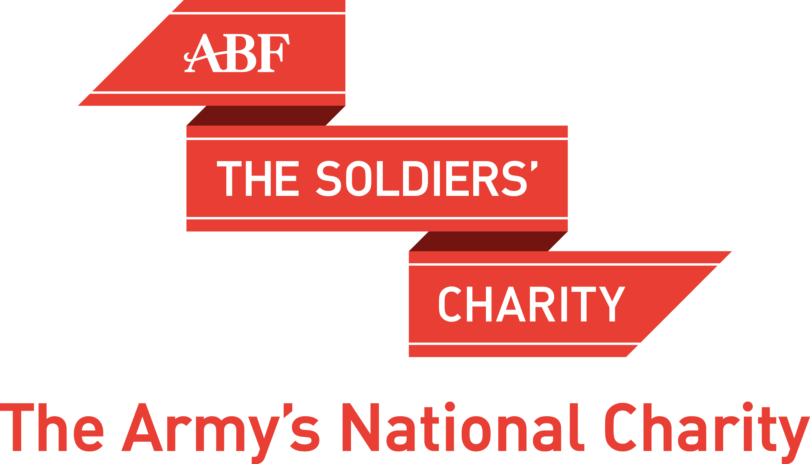

Patron  Her Majesty The Queen | President  General Sir Mike Jackson  GCB CBE DSO DL | Chairman of Trustees  Lieutenant General Philip Jones CB CBE | Chief Executive  Major General Martin Rutledge CB OBE
Brigadier Donald Wilson CBE, Chairman Dorset County Committee
ABF The Soldiers’ Charity, Wyvern Barracks, EXETER, Devon EX2 6AR

01392 496412 southwest@soldierscharity.org soldierscharity.org
www.facebook.com/soldierscharitysouthwest

DORSET BIG CURRY  Sunday 29th March 2020, Bryanston School | 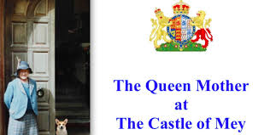

ABF The Soldiers’ Charity (Dorset) is to hold the annual Big Curry on Sunday 29th March 2020 at Bryanston School, Blandford, DT11 0PX by kind permission of the Headmaster, Mark Mortimer. Doors open 12:30 pm; Lunch served from 1:00 pm.
This traditional curry lunch (with a selection of curry recipes) will be cooked by the excellent Bryanston chefs and served in the school dining room. A non-curry option will be available.
At the end of lunch, we will be entertained by an illustrated talk about life with HM Queen Elizabeth, The Queen Mother at the Castle of Mey by Jeremy Mainwaring-Burton (late Irish Guards), formerly Equerry to Her Majesty and later regular guest at the Castle. The afternoon will end with the drawing of raffle tickets.
Tickets: £25.00 per person. A complimentary drink will be served on arrival and a cash bar will be available for wine, beer and soft drinks. Tickets will be issued on a first-come-first-served basis.
- You can buy your tickets online from eventbrite.co.uk and search for “Dorset Curry Lunch”
- Call the office on 01392 496412 and paying by debit/credit card; we will add 61p for postage.
- Pay by bank transfer to ABF The Soldiers’ Charity South West, account number 00782311, Sort code 30-93-14
Please describe your payment as Dorset Curry ticket or Dorset Curry donation.

Alternatively, fill in the form below and send a cheque made payable to “ABF The Soldiers’ Charity” to the address above, enclosing a stamped addressed envelope for your tickets.
Please inform us if you have any special dietary requirements or if you would like to be seated in a specific party.
Please send me ............. tickets @ £25.00 each. Name: ………………………………………………………….

Guest name Dietary requirements if applicable

or I regret that I am unable to attend the Dorset Big Curry Lunch but enclose £……… as a donation.
To save postage costs, a receipt will only be sent if requested.
In order to Gift Aid your donation you must tick the box below:

I want to Gift Aid my donation of £______and any donation I make in future or have made in the past 4 years to ABF The Soldiers’ Charity.
Gift Aid is reclaimed by our charity from the tax you pay for the current tax year. Your address is needed to identify you as a current UK taxpayer. I am a UK taxpayer and understand that if I pay less Income Tax and/or Capital Gains Tax in the current tax year than the amount of Gift Aid claimed on all my donations it is my responsibility to pay any difference.

Our Ref:

Name: Address:

Date of declaration: Signed:

Keep in touch

We would like to keep in touch but we respect your privacy rights. For full details about how and why we collect, use and store your data, visit: https://www.soldierscharity.org/privacy/

If you would like to take this opportunity to confirm your consent for us to send you mailings by post similar to this, please tick this box ( ).

Remember, you can change your mind about how we contact you, or tell us to stop contacting you altogether: Call 01392 496412;
email: southwest@soldierscharity.org ; write to ABF The Soldiers’ Charity, Wyvern Barracks, Exeter, Devon EX2 6AR;

Online: https://www.soldierscharity.org/updatemypreferences/

