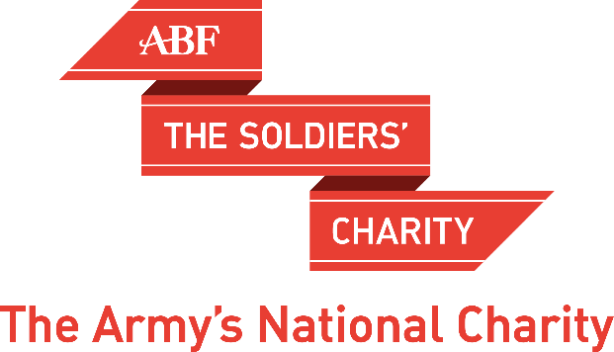

CHRISTOPHER JOLL - ‘Spoils of War’

Over the last seven hundred years, the United Kingdom has acquired a staggering array of ‘spoils of war’ including the Rock of Gibraltar, the Benin bronzes and
Hitler’s last desk. The subject of repatriation or restitution of some, if not all, of these items is now a hot political topic. In his illustrated talk for ABF The Soldiers’ Charity, which will be based on his recently published book, Spoils of War, military historian and former soldier, Christopher Joll, takes a robust and
sometimes controversial view of the issues.

‘If you say yes to one, you suddenly find the British Museum would be empty… I am afraid to say, to disappoint all your viewers, it is going to have to stay put.’
- The Rt Hon David Cameron, when asked on Indian TV in 2010 about the
return of the Koh-I-Noor diamond

Christopher will address the controversies surrounding the acquisition, retention and possible restitution of a wide variety of ‘spoils’ in Britain’s royal, national,
regimental and private collections. Along the way, he will debunk a number of myths, expose a major fraud perpetrated on a leading London museum and relate some gruesome military-historical stories.
The Inner London Committee of ABF The Soldiers’ Charity
invites you to a Reception followed by a Talk
on Tuesday 27th October 2020
at London Scottish House, 95 Horseferry Road,
London SW1P 2DX
Drinks at 6:30pm for a 7:15pm Talk
This talk is not for the faint-hearted

Arrangements for this event are subject to change but we are
planning to go ahead as usual with 30 places
available in the Drill Hall. We will livestream the event for those who cannot be there in person.

For enquiries please call 020 3903 6030 / 07817 141 033 /07875 154 847
or email ghogarth@soldierscharity.org

TICKET APPLICATION FORM

For return address by post: Gerardine Hogarth, ABF The Soldiers’ Charity, Wellington Barracks, London SW1E 6HQ (Post will only be picked up once or twice a week so please email/call to
reserve a place).

Please tick this box to confirm that you would like us to continue sending you emails like this [ ]

I would like ………….. tickets (at £35 each) for ‘Spoils of War’
I would like ………….. virtual places (at £20 each) for ‘Spoils of War’

To pay by BACS please make contact with Gerardine Hogarth at ghogarth@soldierscharity.org

I enclose a cheque for £ ………………. made payable to ABF The Soldiers’ Charity

The full names of my party (including me) are:

………………………………………………………………….……………………………………………..............................

............................................................................................................................................................

Please send tickets to my email address: ………………………………………………………………………..…….

OR I cannot attend, but enclose a donation to the charity of £……………………………………………….

Boost your donation by 25p of Gift Aid for every £1 you donate.
In order to Gift Aid your donation you must tick this box: □

I want to Gift Aid my donation and any donations I make in the future or have made in the past 4 years to ABF The Soldiers’ Charity. I am a UK taxpayer and understand that if I pay less Income Tax and/or Capital Gains Tax than the amount of Gift Aid claimed on all my donations in that tax year it is my responsibility to pay any difference.

Title*:……… Forenames*: ………………………………………………Surname*:…………..…………………………….

Home Address*:………………………………………………………………………………………………….…………………..

…………………………………………………………………………………………… Postcode*:……………….………………..

Email:……………………………………………………………………………… Tel No:……………………………….

(*Required for Gift Aid) Date of declaration*: ……../……./……..

Please help us keep our records up-to-date by telling us if your contact details and other personal information change. You can change your mind at any time about keeping in touch or tell us to stop contacting you altogether:
To tailor your preferences go to: www.//soldierscharity.org/updatemypreferences
- To unsubscribe go to: www.//soldierscharity.org/unsubscribe
- Or, contact our local office, see above, and we will make the changes for you.
- For full details about how and why we collect, use and store your data go to: https://www.soldierscharity.org/privacy/

