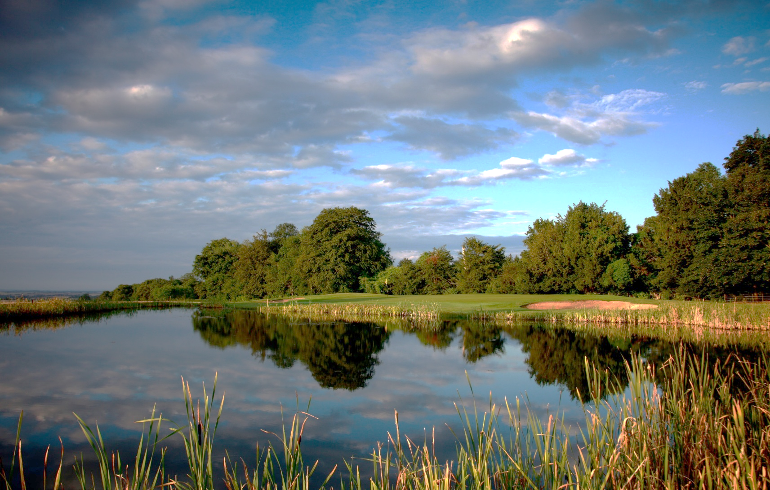

Team Name
Tel and e-mail
Contact Address
 | Name | Handicap  Index |  | Name | Handicap  Index
Captain |  |  | Player 2
Player 3 |  |  | Player 4
Please return this form with a cheque for £200 for the whole team payable to ABF The Soldiers’ Charity to:
Colonel (retired) C E Price OBE
52 Bell Street
Shaftesbury Please tick/cross if you have paid by BACS
Dorset SP7 8AE
christophereprice@btinternet.com Approximate tee off time preference……………………...
Please note the e after christopher!
01747 851 853
0774 0776 422
Or, by BACS: Barclays, Sort Code 20-00-00, Account No 33922952, ABF The Soldiers’ Charity-SW Bulford
Please return the completed form to the address above. Closing date: Friday 12th August
I am unable to play but I would like to make a donation and enclose a cheque for £…………...
Please book early!

I am unable to play, but I would like to make a donation and enclose a cheque for £………………

Charity Golf Day
in aid of ABF The Soldiers’ Charity
Rushmore Golf Club near Shaftesbury
Friday 16th September 2022 (rolling start 9am-1pm)
4-ball team Stableford event (handicap required)
Best two scores from four on each hole

Prizes include: nearest the pin, longest drive
£50 per person
Includes coffee and bap on arrival and a two-course lunch

ABF The Soldiers’ Charity is the Army’s National Charity providing a lifetime of support to soldiers, veterans and their immediate families in times of need. Our total charitable expenditure for 2020-2021 was £8.2M, ensuring a complete spectrum of support to more than 60,000 members of the Army family in 62 countries. The youngest person supported was two, the eldest,102. We funded 43 other charities that provide support to the Army family.
Charity Golf Day in aid of ABF the Soldiers’ Charity
Friday 16th September 2022

On behalf of the Chairman of the Army Benevolent Fund the Soldiers’ Charity Committee for Dorset, Brigadier Donald Wilson CBE, may I take this opportunity to invite you to take part in our charity golf day on Friday 16th September 2022 at Rushmore Golf Club, Tollard Royal.

- This Stableford event is open to anyone with a handicap index (Maximum: Ladies 36, Gentlemen 30). Handicaps should be submitted on the application form, but will be adjusted at Registration on the day in line with the WHS Course Handicap Table. The day will consist of a rolling start from 9am-1pm with four-ball teams, which may be mixed. Ladies will play off red tees and gentlemen off yellow tees. Best two scores from four on each hole. Prizes include: first, second and third places, nearest the pin (x4), twos’ competition and the longest drive. There will also be a raffle and a silent auction.

- The cost is £50 per person including coffee and bap on arrival and a two-course lunch (menu details to follow). See attached application form with postal address. BACS or cheques only. The closing date for applications is Friday 12th August.

- The Clubhouse will be open for registration, coffee and baps from 8am. Teams should register at the registration desk half an hour before their tee off time. Scorecards and any additional playing instructions will be issued at the desk. More details will follow in the team captains’ information sheet including tee off times. If you have a preference for an approximate tee off time please include it on the application form and I will do my best to accommodate it.

- Contact Numbers:
  - Clubhouse 01725 516466
  - Pro Shop 01725 516326

- Address: Rushmore Golf Club, Tollard Royal SP5 5QB

- Golf Club Web Page: www.rushmoregolfclub.co.uk

I do hope you will consider putting a team together and supporting ABF the Soldiers’ Charity. I look forward very much to hearing from you. Please call or e-mail me if you wish further information.

With Best Wishes

Christopher Price
Event Organiser
01747 851 853
0774 0776 422
christophereprice@btinternet.com
We are expecting a large number of applications, therefore you are advised to book early. A cheque/BACS will secure you a place on a first come first served basis

